**Sennheiser’s Full TeamConnect Family Set to Shine at Integrate 2024**

***The latest cutting-edge audio solutions from Sennheiser will be showcased at Sydney's premier annual AV and integration trade show, Integrate 2024.***

***Sydney, Australia –* 13 August 2024** – Sennheiser, the first choice for advanced audio technology that makes collaboration and learning easier, is set to return to Integrate 2024 in Sydney from August 21-23. The Sennheiser stand (B16) will feature the latest products from the TeamConnect Family, along with other key highlights from their comprehensive business communication portfolio. Visitors can look forward to the launch of the Perfect Pair hunt at Integrate 2024, previously a hit at this year’s ISE and InfoComm Las Vegas, where participants can connect with Sennheiser’s network of Global Partner and Alliances for a chance to win exciting prizes.

**Tech Talk: Sennheiser’s Vision for Campus AV Excellence**

Further supporting education institutions on the importance of optimised AV environments, Daniel Rowe, Business Development Manager for Business Communication at Sennheiser, will participate in a Tech Talk panel discussion alongside spokespeople from AETM/Swinburne University of Technology and Presbyterian Ladies’ College Melbourne.

The panel, titled ‘[*Adapting to the Future: How to Support the Ever-Evolving Expectations of your Campus Community*](https://integrate-expo.com/whats-on/tech-talks/)*,’* will take place on **Thursday 22 August** **4:00 pm to 4:50 pm** with a discussion on the latest trends on the horizon related to student, faculty and staff collaboration, and how to equip educators and administrators with tools for evolving AV environments.

**Showcasing the Full TeamConnect Family**

Experience the full TeamConnect Family at Integrate 2024, a range of advanced audio solutions designed for modern meeting and learning spaces. From the award-winning TeamConnect Ceiling Medium to the newly launched TeamConnect Bar Solutions, these products offer best-in-class audio, seamless integration, and versatile installation options.

*A display of Sennheiser’s TeamConnect Solutions Bar*

"We're extremely proud of the products we develop and we’re equally excited to showcase that innovation at Integrate 2024. Our team shares such passion for this industry and for us, Integrate is the perfect setting to engage with the AV community and share the technological strides we've been making. The TeamConnect product suite exemplifies our commitment to technology leadership and we're eager for attendees to discover its full range at our booth," shared Jason Grbevski, Sennheiser ANZ's Sales Director of Business Communication. "Being part of Integrate is about more than just presenting products and demos. It's an opportunity to rekindle relationships and grow our community of like-minded organisations, all of whom are pushing the boundaries of tech innovation. That's why we're kicking off the Perfect Pair campaign at this year's Integrate, a digital scavenger hunt that is open to anyone visiting the Sennheiser booth, as well as our Global Partner and Alliances booths. Giving visitors a chance to win fantastic prizes, including a TeamConnect Bar M.”

**Experience the Future of Conferencing with TeamConnect Bar Solutions**

Explore the newly launched TeamConnect (TC) Bar Solutions at Sennheiser’s TC Solutions demo bar.

Equipped with powerful built-in microphones, speakers, a 4K Ultra HD camera, and Dante integration, the TC Bar S and TC Bar M provide scalable solutions for small to mid-sized meeting spaces. These advanced systems ensure top-tier audio quality and seamless integration. Both easily integrate with any meeting platform and can be further enhanced with other compatible products, including those from Sennheiser.

TC Bar Solutions provide the most feature-rich conferencing options in their class and are now available for order.

*The TeamConnect Bar Solutions being used in a meeting room.*

**On Display: TeamConnect Ceiling Medium and MobileConnect**

The TeamConnect Ceiling Medium (TCC M), celebrated for its award-winning design and exceptional sound quality, seamlessly integrates into any hybrid meeting or learning space. Its adaptive, intelligent beamforming technology guarantees flawless audio, transforming any room into a collaboration hub. Perfect for both corporate and educational settings, the TCC M provides versatile installation options and single-cable integration, elevating any environment with top-tier sound.

**AVIA Awards Finalists Live Announcement**

[Flinders University](https://newsroom.sennheiser.com/educational-innovation-led-by-sennheiser-technology-at-flinders-universitys-adelaide-campus) is shortlisted for Best Application of AV in Education, and Sennheiser is nominated alongside Diversified. The new city campus at Festival Plaza, designed with Diversified and Sennheiser, boasts cutting-edge AV infrastructure, including Sennheiser’s TeamConnect Ceiling 2 and SpeechLine Digital Wireless systems, both of which will be featured at the Sennheiser booth. These technologies enhance teaching, learning, and collaboration across over 100 digitally enabled spaces, setting a new benchmark in hybrid and in-person education.

The award winners will be announced at the conclusion of Day 1 of the show, from 5:30pm.

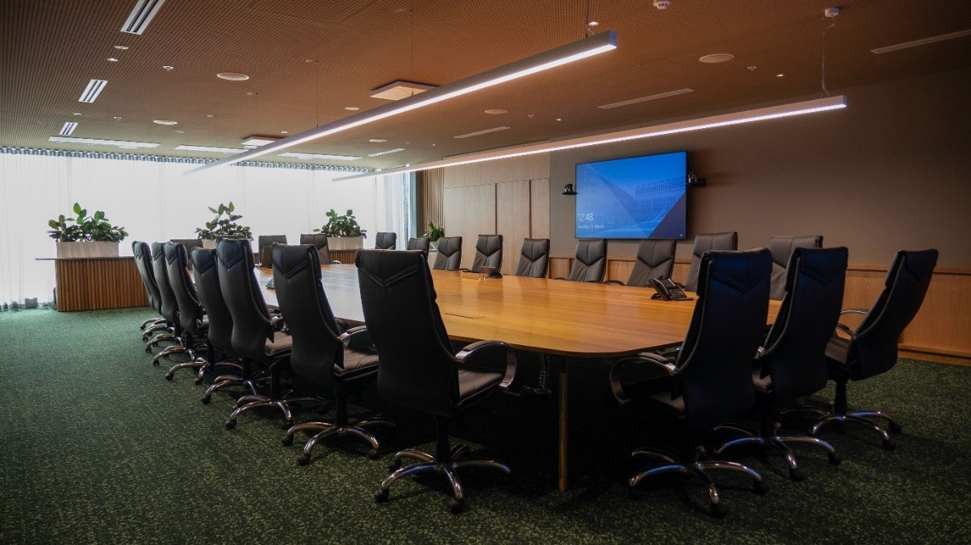

*An example of the Flinders University boardroom equipped with Sennheiser gear.*

**Global Partner and Alliances**

Sennheiser continues to collaborate with leading manufacturers like AUDAC, Barco, Crestron, Lightware, Lumens, MAXHUB, Netgear, and Q-SYS. Discover how these partnerships enhance integration and deliver engaging experiences, whether you're an integrator, consultant, or technology user. These Global Partners and Alliances will be actively participating in Sennheiser’s Perfect Pair Scavenger Hunt at Integrate 2024. “Collaborating with other top industry players helps us create even better solutions for our users. We can’t wait to show off these collaborations at Integrate” said Jason Grbevski.

Join the hunt via the Deckle App and visit our Global Partners and Alliances for a chance to win exciting prizes, including a TC Bar M, Sennheiser Profile USB Microphone, Sennheiser ACCENTUM Wireless Headphones, or a Sennheiser Hoodie. Plus, participants will get exclusive limited edition Sennheiser socks!

More information about Sennheiser at Integrate 2024 can be found [here](https://www.sennheiser.com/en-au/events/integrate). To book an appointment during the show, please get in touch with the press contact listed below

###

**About the Sennheiser brand**

We live and breathe audio. We are driven by the passion to create audio solutions that make a difference. Building the future of audio and bringing remarkable sound experiences to our customers – this is what the Sennheiser brand has represented for more than 75 years. While professional audio solutions such as microphones, meeting solutions, streaming technologies and monitoring systems are part of the business of Sennheiser electronic GmbH & Co. KG, the business with consumer devices such as headphones, soundbars and speech-enhanced hearables is operated by Sonova Holding AG under the license of Sennheiser.

[www.sennheiser.com](http://www.sennheiser.com/)

[www.sennheiser-hearing.com](http://www.sennheiser-hearing.com/)

|  |  |
| --- | --- |
| **Local Press Contact**  Kirsten Spruch  kirsten.spruch@sennheiser.com  +1 (860) 598-7484 | Hotwire Australia  [sennheiseranz@hotwireglobal.com](mailto:sennheiseranz@hotwireglobal.com) |
|  |  |